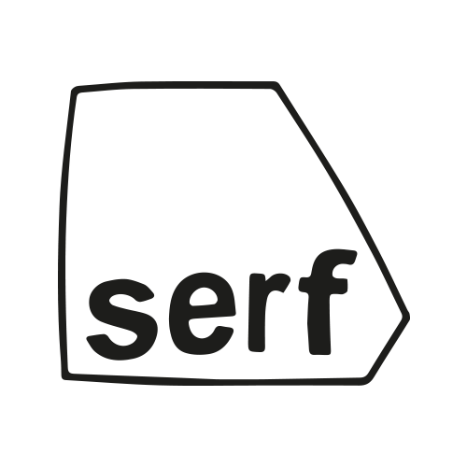

Serf Artist-Led Studios & Project Space

Proposal Application March Open Call

|  |
| --- |
| **Personal Details**  Name of Artist/ Artists/ Collective/Curator/ other (please note):  Please name artists if you intend to curate a show: |
| **Synopsis of Exhibition/Project/Event (maximum 1000 words)** |
| **Who is your exhibition aimed at and why?**  ***Optional:* Would you like to plan orbiting events in the 2 weeks of the show being open (eg. Artist Talk, Group Discussion etc, and how would you like Serf to help make this work)** |
| **Artform/ Media/ Plans for Works**  Please describe the ideas around work(s)/desired work(s) that will be included in the exhibition  How might you utilise the Serf Project Space? (optional) |
| ***Please attach a minimum of 5 images/drawings to this form, collated in a PDF. Feel free to send over any sound or film work as links or compressed files.*** |

*Important: Please note that at present Serf is run by a group of volunteers, and operates without funding. In turn we facilitate exhibitions rather than invite artists to show in our space. If your proposal requires financial support please let us know how we can assist you in achieving this.*